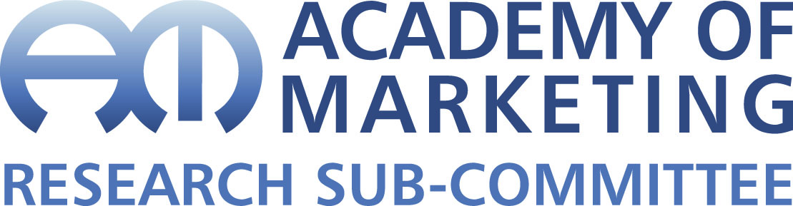**

**Application form to host Academy of Marketing Early Career Researcher (ECR) Capacity Building Workshop**

*The Academy of Marketing ECR Workshops aim to build capacity among members. The focus of the workshops should be on areas of broad general interest for members. It is possible to organize more subject specific workshops through the relevant Special Interest Groups (SIGS). For those wishing to propose a capacity building workshop, please complete the following form which will be assessed by the Early Career Research Sub-Committee. Organizers should aim to facilitate participation by keeping any fees as low as possible. Up to £4,200 funding is available from the Academy of Marketing to support a workshop and this can be included in your costings. Costing should not include academic time, but time for other support functions is allowable.*

|  |
| --- |
| **Title/Topic:** |
|  |
| **Venue:** |
|  |
| **Proposed Date:** |
|  |
| **Contact Host Details:** |
|  |
| **Short description of workshop (max 300 words):** |
|  |
| **Justification of need in terms of potential to increase capacity for AM members (max 500 words):** |
|  |
| **Expected audience** (doctoral students/ ECRs/ Mid Career/ Established Academics): |
|  |
| **Proposed programme:** |
|  |
| **Proposed budget:** |
|  |
| **Requested AM contribution:** |
|  |